Project Design Phase
Phase 3: Import Set Table
The Project Design Phase defines the overall structure and workflow for importing employee data from an external spreadsheet into ServiceNow. The design focuses on creating a simple, reliable, and efficient data-import process using Import Sets and Transform Maps.

1. System Design
The project will follow a structured data-import workflow:
Excel Spreadsheet → Import Set Table → Transform Map → Target Table → Data Validation
The Excel file acts as the source of employee information. The data is first loaded into a temporary Import Set table. A Transform Map is then used to map and transform the source fields into the corresponding fields in the target table.

2. Module Design
The project will consist of the following major components:
- Source Data: Excel spreadsheet containing employee information.
- Import Set: Temporarily stores the uploaded spreadsheet data.
- Import Set Table: Acts as the staging table for the imported records.
- Transform Map: Defines the relationship between source and target fields.
- Field Mapping: Maps employee information to the appropriate target fields.
- Target Table: Stores the final employee records.
- Validation: Verifies that the imported records are accurate and complete.

3. Data Flow Design
Step | Component | Description
1 | Excel File | Contains structured employee data
2 | Import Set | Uploads the spreadsheet into ServiceNow
3 | Import Set Table | Temporarily stores source records
4 | Transform Map | Defines source-to-target field relationships
5 | Field Mapping | Maps individual employee fields
6 | Transform | Converts and transfers the data
7 | Target Table | Stores the final employee records
8 | Validation | Verifies the imported information

4. Field Mapping Design
The Transform Map will be designed to map the source spreadsheet fields to the appropriate target fields.
Source Field | Target Field
Employee ID | Employee ID
Employee Name | Name
Email | Email
Department | Department
Job Title | Job Title
Phone Number | Phone
Location | Location

5. Process Design
The implementation will follow these steps:
- Prepare the employee data in Excel format.
- Upload the spreadsheet into ServiceNow.
- Create or use an appropriate Import Set Table.
- Create a Transform Map.
- Configure the required field mappings.
- Execute the transformation.
- Check the transformation results.
- Verify the employee records in the target table.
- Identify and correct any errors or invalid data.
- Confirm that the final data is accurate and complete.

6. Security and Data Integrity Design
The design should ensure that only authorized users can perform data imports and transformations. Employee information should be handled securely, and appropriate validation should be performed to prevent incorrect or incomplete records from being added to the target table.

Import Set Table
Navigation:
In Application Navigator → Load Data
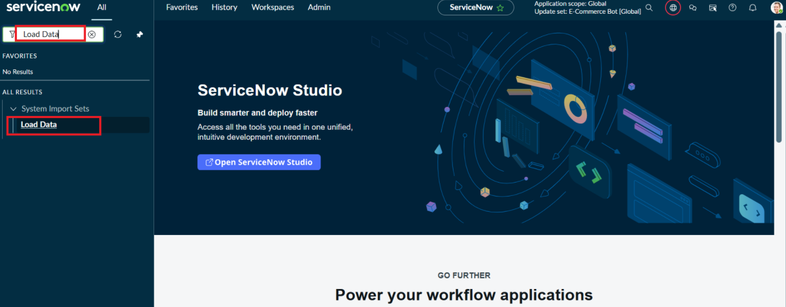
Click on Load Data and create an import table
Fill details as shown below
- Label: Employee Import
- Name: u_employee_import (auto populated)
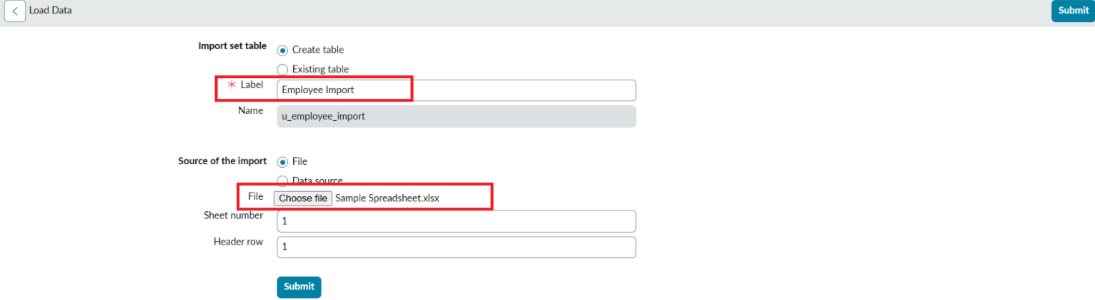

- Click on Submit
Once we click on Submit, we can see the success message as shown below.

Also we need to make sure to click on Create Transform Map.

